CAFÉ - High Flow Analysis Tool

Link: <https://andrewdelsanto.shinyapps.io/highflowdss/>

Description: This webtool is designed for assisting resource managers in calculating extreme high flows at, or near, a USGS streamgage, as well as estimating 100-year-floods in purely ungaged basins. Additionally, the tool allows the user to apply the effects of climate change to the estimates using a methodology from the Transportation Research Board’s NCHRP 15-61: *Applying Climate Change Information to Hydrologic and Hydraulic Design of Transportation Infrastructure*.

The gaged portion of the tool is recommended for gages and locations slightly down or upstream of a gage where the ungaged watershed area is within 50% of the gaged watershed area:

At a gage or where $\left[0.50< \frac{Ungaged Watershed Area}{Gaged Watershed Area}<1.50\right]$

Summary of Steps:

1. Download Streamflow Data
   1. Enter an 8-digit NWIS gage number and press “Download Streamflow Data”.
   2. All available streamflow data is downloaded and stored.
   3. The first and last date of available streamflow data are displayed.
2. Display Streamflow
   1. Display Summary Statistics (Quantile Flows) on Left
   2. Plot Unrefined Streamflow Data with Quantile Lines
3. Display Streamflow (Log Scale)
   1. Display Summary Statistics (Quantile Flows) on Left
   2. Plot Unrefined Streamflow Data with Quantile Lines
4. Mann-Kendall Test for Trends in Annual Peaks
   1. Run Mann-Kendall Test
   2. Plot with Smoothed Trend Line
5. Plot Annual High Flows
   1. Display High Flow Statistics (25, 50, and 100-Year-Flood) on Left
   2. Plot Log-Pearson Type 3 Flood Frequency Plot
6. Subset Data
   1. New Graph is Displayed
   2. Dates are Used to Subset/Trim Data
   3. Pressing “Save New Data” Saves Subset
7. Plot Low Flows – Subset Data
   1. Display High Flow Statistics (25, 50, and 100-Year-Flood) on Left
   2. Plot Log-Pearson Type 3 Flood Frequency Plot
8. Flow Scaling
   1. Enter New Watershed Area
   2. Press “Direct Area/Area Flow Scaling”
   3. Results from Step 7 are scaled up/down and displayed again.

## Step by Step Walkthrough and Notes

Step 1: Download Streamflow Data

The program begins by allowing you to download the streamflow data from an NWIS streamgage. This assumes that you know the 8-digit gage number for a streamgage that is active and has continuous daily data. Note, this will not work with partial record stations.

If you would like to see a map of current NWIS streamgages, you can use the new National Water Dashboard, which has an interactive map showing gages and their most recent discharge data (<https://dashboard.waterdata.usgs.gov/app/nwd/en/?region=lower48&aoi=default>).

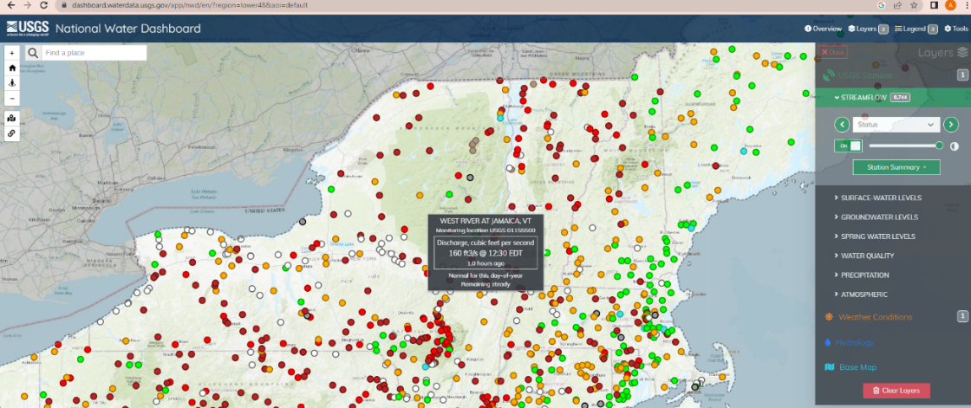

Opening the program should bring you to a page that looks like this:

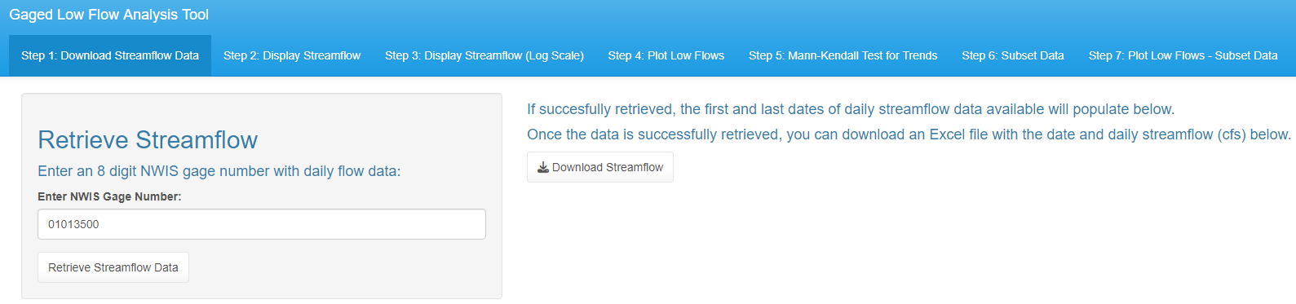

After entering a gage number that corresponds to an active, continuous NWIS gaging station, press the “Download Streamflow Data” button and the program should display the following messages (note, this may take 5-30 seconds):

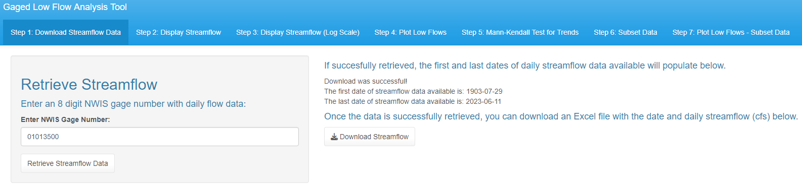

Note: After retrieving the streamflow, you can click “Download Streamflow” and the following will download:

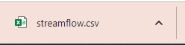

Step 2: Display Streamflow

In this tab, we display the raw daily streamflow data. In this example, you can see that there is a glaring gap from around 1915 until around 1930.

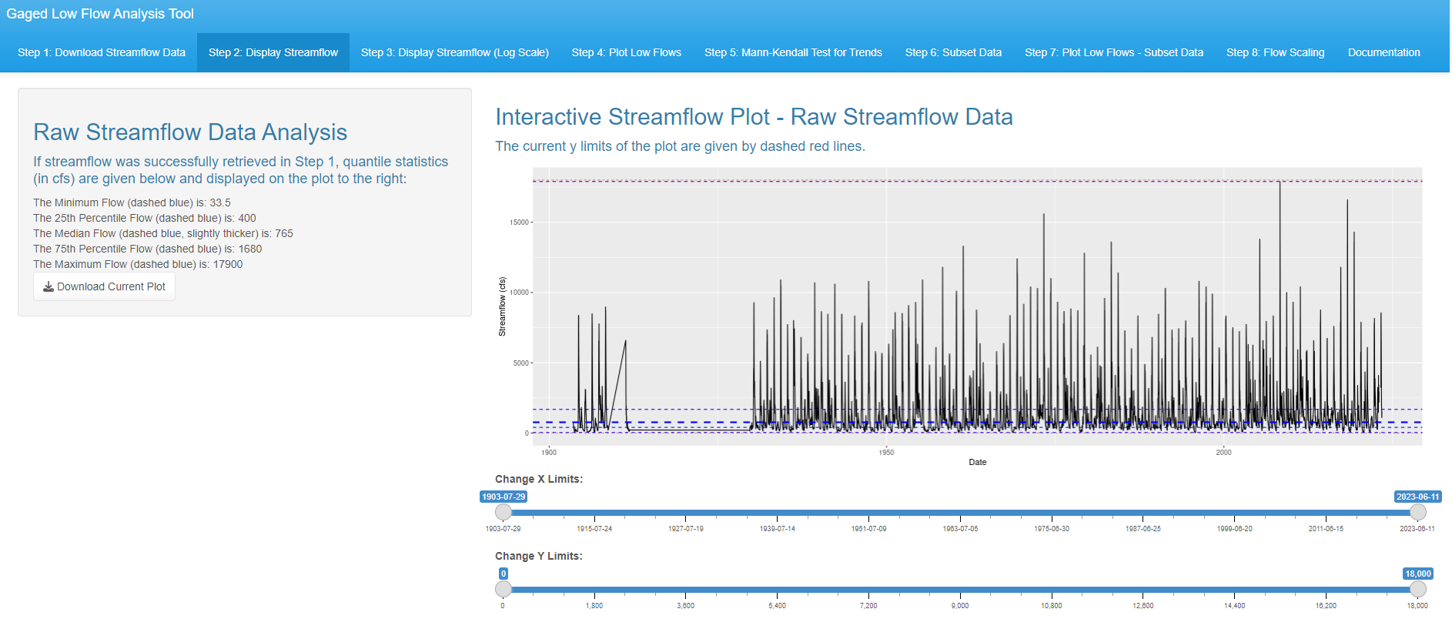

The side panel on the left should display the minimum, maximum, 25th, 50th, and 75th percentile flows. These are displayed just to give you an idea of what the average flows are for the gage.

Depending on the size of the basin, the plot may be difficult to discern. The example given above uses a large basin in Maine (01013500) and as a result, some of the streamflow values are so large that it is difficult to even see the 75th percentile flows. Because of this, we provide sliders that allow you to analyze specific x limits and y limits of the data. For example, let’s say you just want to look at the last 10 years of data. This is what happens if you put the x slider to roughly the last 10 years.

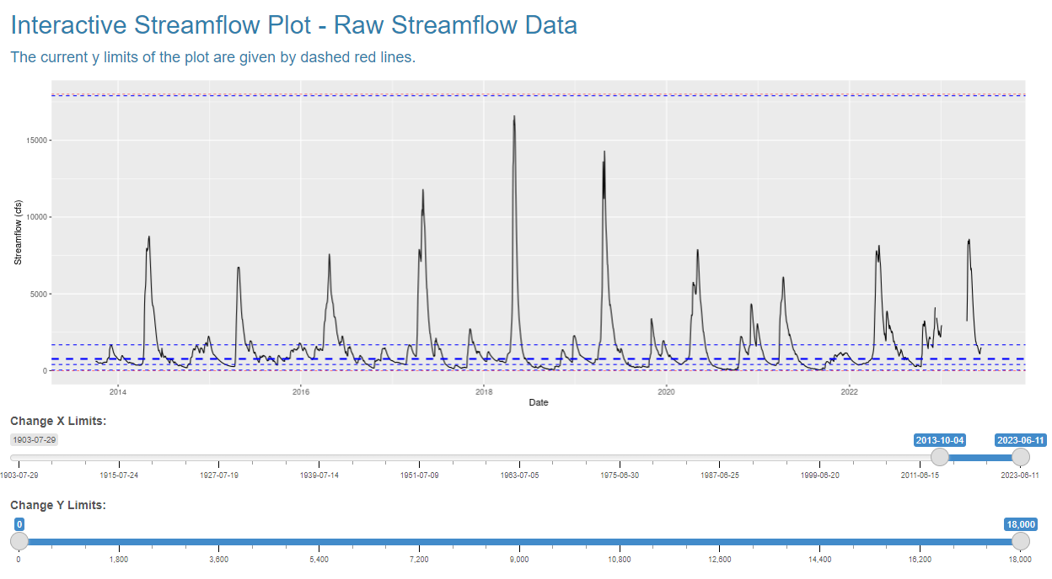

Feel free to experiment with this tab. Hopefully this provides some streamflow analysis utility for you.

Note- pressing the “Download Current Plot” button downloads whatever is currently shown in the plot (as a .jpg), not the original full streamflow plot, so you can download multiple plots from this tab.

Step 3: Display Streamflow (Log Space)

Because of the difficulties that arise from plotting streamflow normally, it is very common to plot streamflow with a y axis that is in log scale. For that reason, in this tab, we also plot the streamflow with a log y scale. The tab should look like this:

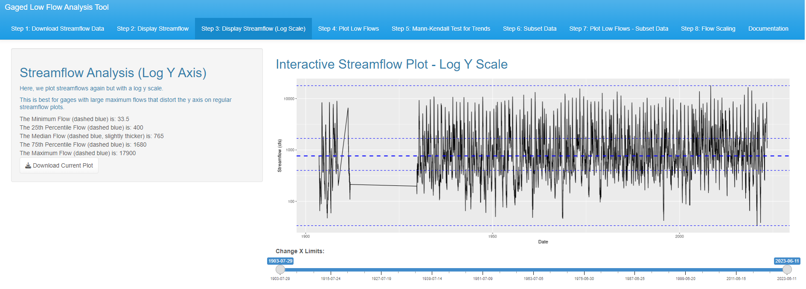

Because of the log scale on the y axis, which is meant to allow you to see the full range of y values everywhere, we only provide a slider for changing the x limits of the plot. Once again, let’s look at the last 10 years:

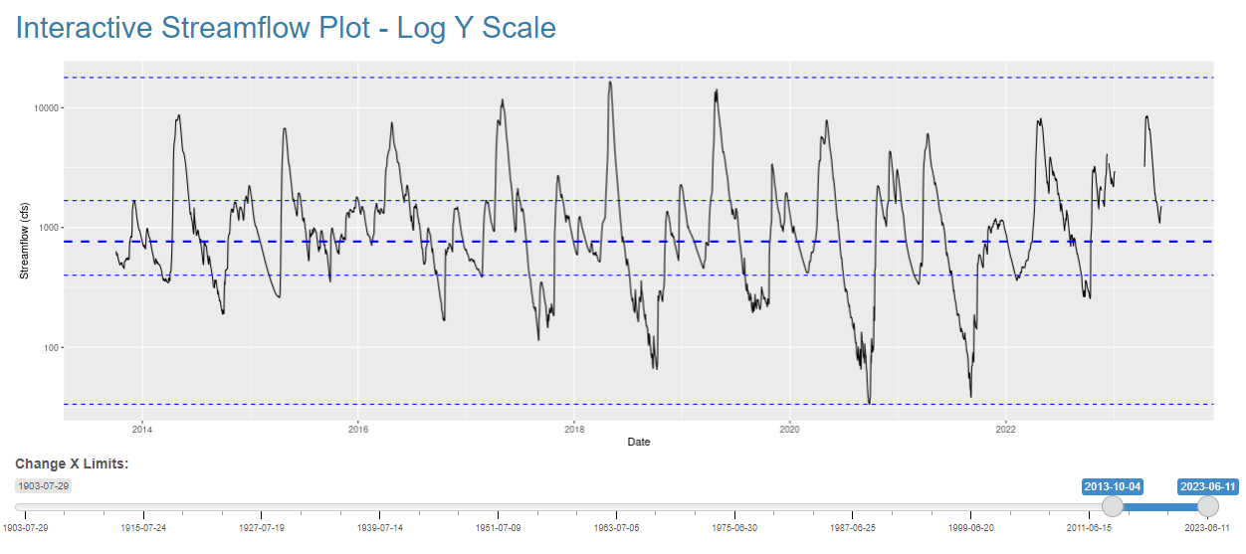

Notice that you can see the full range of streamflow values easily given the log y scale, and that the dashed lines mimic the quartiles of a box plot. Because streamflow is always very skewed (mostly small values but a few massive values), this graph looks more like a timeseries that is normally distributed around a median value at the thick, dashed line in the middle.

Once again, you can download the current active plot by pressing “Download Current Plot” and this should show up in your downloads bar:

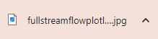

Note: Downloading multiple plots will automatically add a (1), (2), … (n) after each downloaded plot, depending on the number of plots you download in one singular tab.

Step 4: Plot Low Flows

In this tab, we display only the lowest 10th percentile flows with another slider to play around with the x axis limits. We also calculate low flow metrics from the full record of streamflow data, including the 7Q2, 7Q10, and 7Q30, using the fasttr package (https://cran.r-project.org/web/packages/fasstr/vignettes/fasstr_users_guide.html).

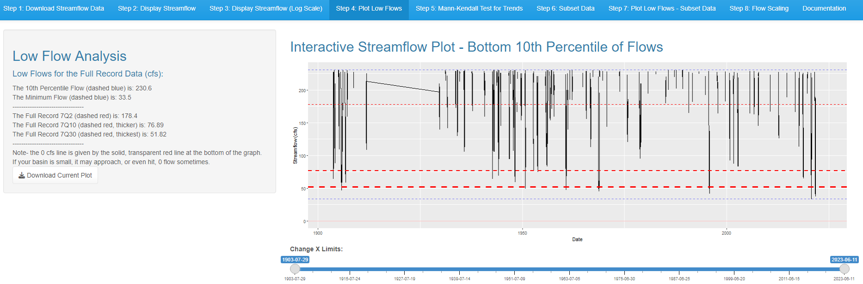

The low flows are given in the left side-panel and are also shown on the plot. As you go from most frequent (7Q2) to less frequent (7Q10) and least frequent (7Q30), the dashed red lines get thicker to signify drier and drier conditions. The lowest daily flow on record is given by the bottom dashed blue line, and a dark red line at the bottom signifies no (0) flow.

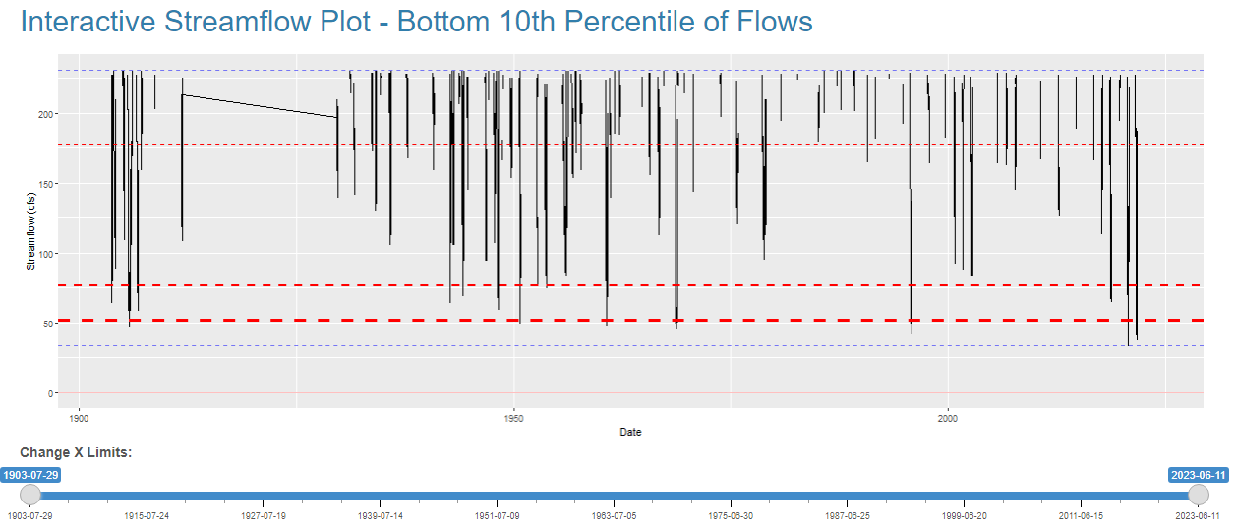

Note- Smaller basins tend to get less cumulative precipitation than larger basins, so smaller basins may have a minimum flow or 7QN of 0 flow. This is the same plot for gage 01658500, which completely dries up (on average) every ~5 years. The 7Q2 is above 0, but the 7Q10 and 7Q30 are both 0cfs.

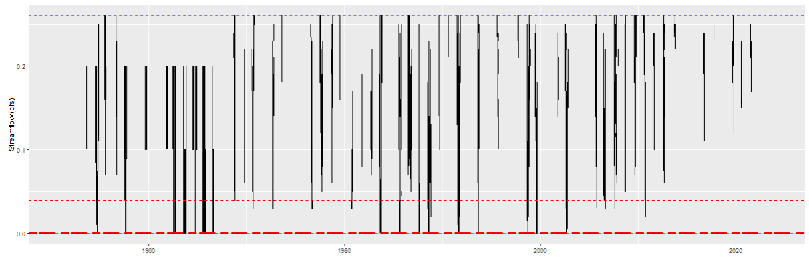Step 5: Mann-Kendall Test for Trends

Blum et al. (2019) (https://sites.tufts.edu/richardvogel/files/2019/09/Blum-et-al.-HSJ-2019.pdf) suggests only using the last 30 years of streamflow data to calculate the 7Q10 when an increasing or decreasing trend is detected in the annual 7-day low flow data. For that reason, we are including a tab to test that.

Note: if you have a required procedure to calculate the 7Q10 (e.g. only using the last 30 years of data), you can skip this tab unless you are curious if there is a trend in the annual low flow data.

When you open the tab, it should show this:

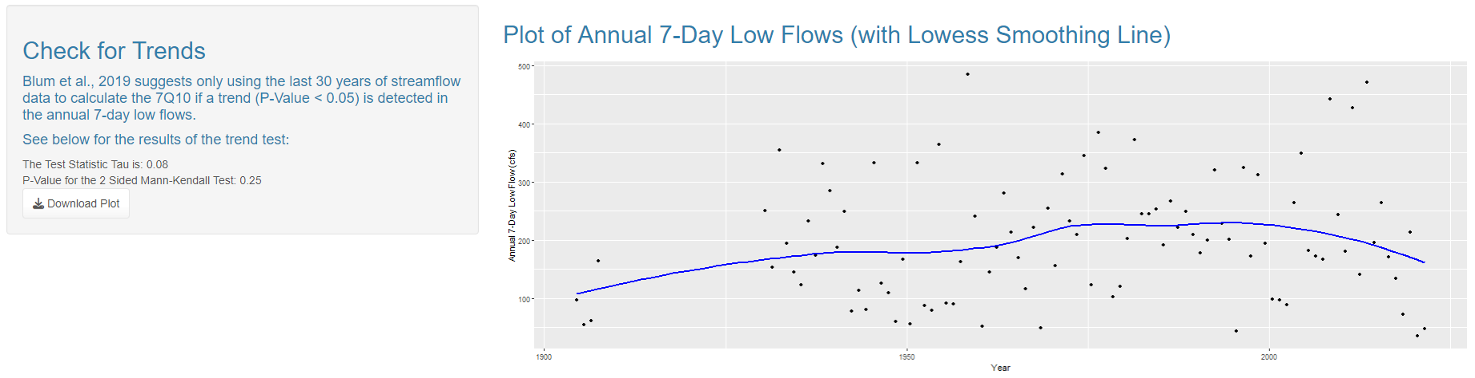

Here, we use the “Kendall” package (<https://www.rdocumentation.org/packages/Kendall/versions/2.2.1>) to calculate the Mann-Kendall test statistic and P-Value. We also plot the annual 7-day low flow data in the main panel and overlay a smoothed trend line using the Lowess function in base R.

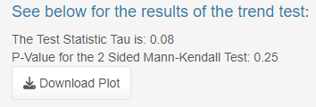

In this example, the trend test P-Value is 0.25. Most statisticians use a P-Value threshold of 0.05 to determine if there is a notable trend, and the Blum paper also recommends using a P-Value of 0.05. Because the test P-Value of 0.25 is larger than 0.05, we failed to detect a statistically significant trend.

Note- In this tab, we are only showing you the results from this Mann-Kendall test. The results from this tab will not affect anything else going forward unless you choose to follow the procedure given in Blum et al. (2019) in the next tab, where you can choose to subset the streamflow data to your liking.

Step 6: Subset Data

As mentioned before, you may want to subset the raw streamflow data for a number of reasons (there may be a large gap in the data, you may be required to use a more recent subset of streamflow data to calculate the 7Q10, etc.). In this tab, we allow you to choose a subset of data for all future analyses.

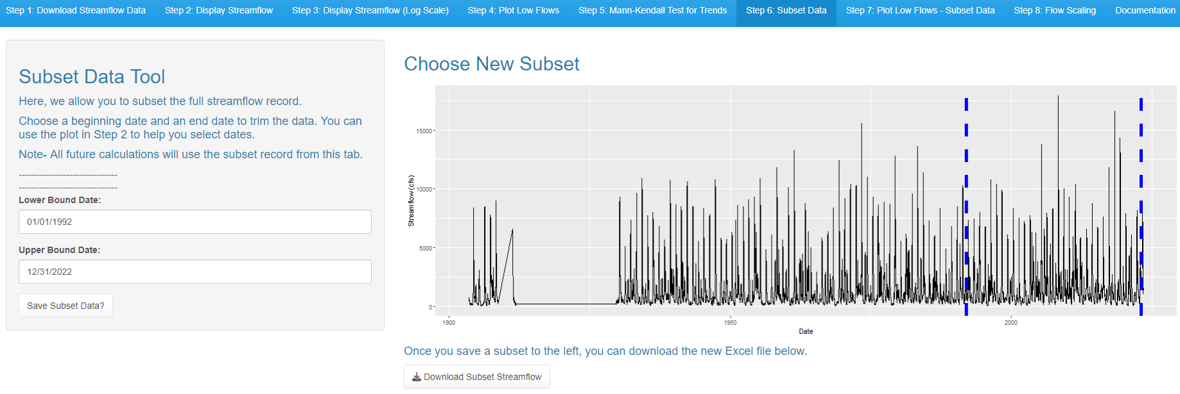

Clicking either the lower bound date or upper bound date box will open a calendar selection. You can either select the date from the calendar pop-up or type it in manually.

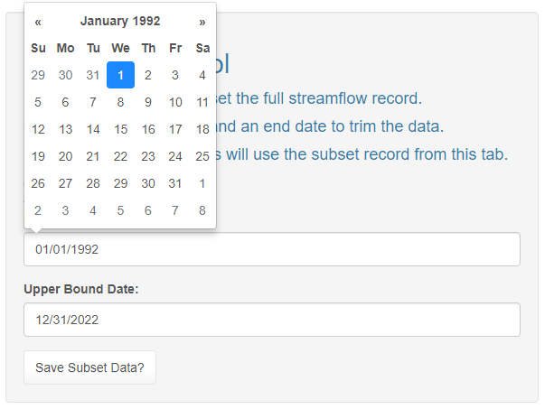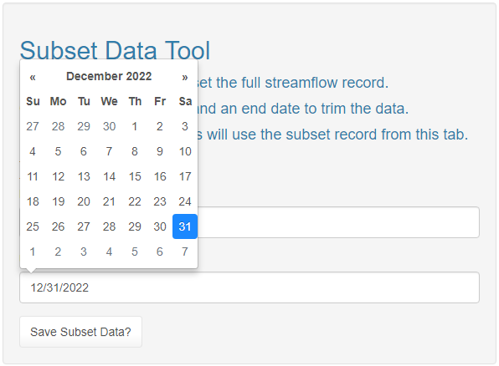

You may notice that the graph automatically updates to show the new subset dates.

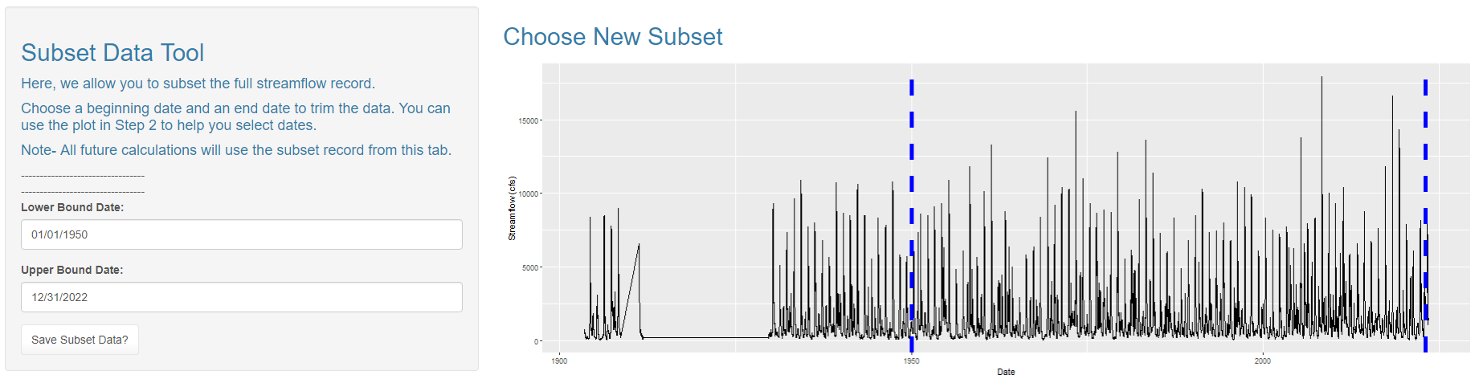

When you are satisfied with the dates, click “Save Subset Data?” and it should tell you that your new subset is saved below the button.

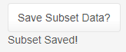

Once the subset is saved, you can download the streamflow data (in an Excel file) between your subset dates.

Step 7: Plot Low Flows - Subset Data

In this tab, we plot the same graphic as in Step 3, but we use the data from the subset streamflow data instead. We also include the previous full-record 7Q2, 7Q10, and 7Q30 as semi-transparent lines.

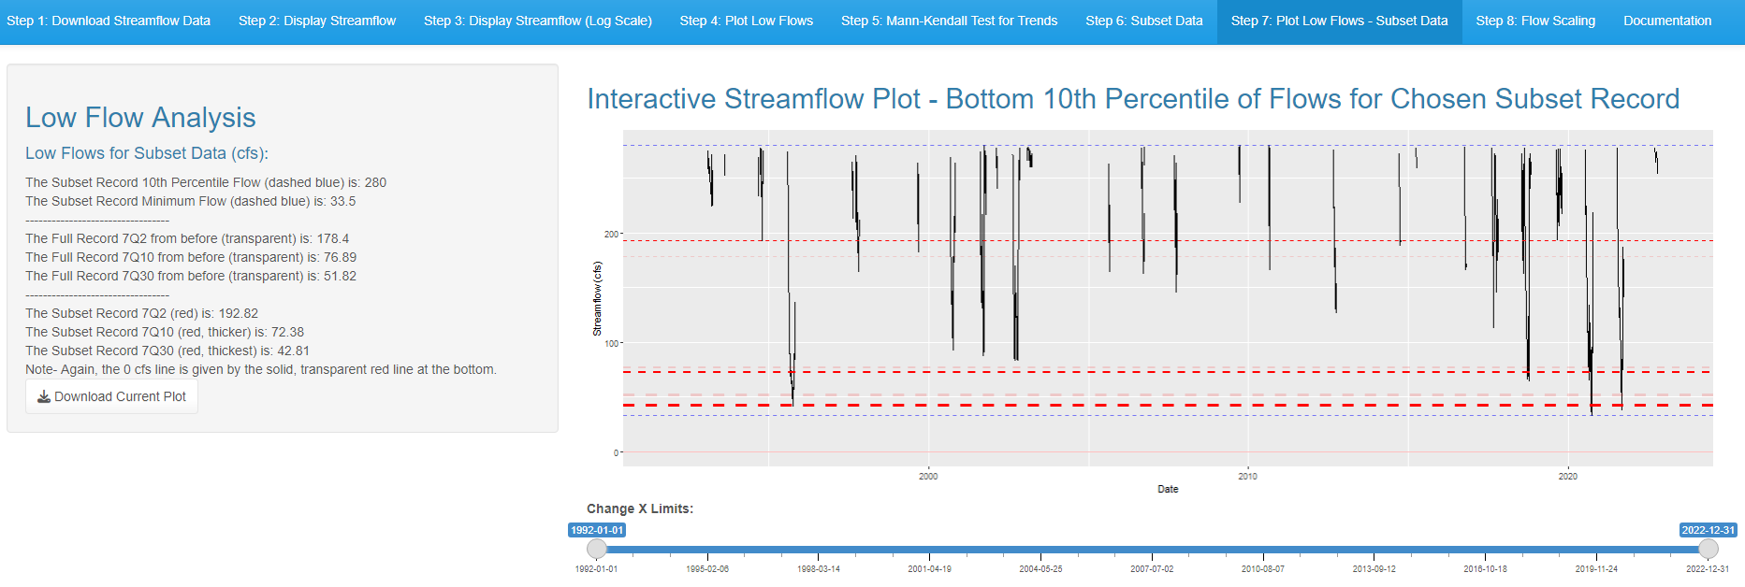

The new 7Q2, 7Q10, and 7Q30 should be different from the values calculated before using the full record. Notice that at this gage, the 7Q2 has actually increased slightly, while the 7Q10 and 7Q30 have decreased. This suggests that every two years, the worst 7-day low flow is slightly wetter than in the past, while the 10-year and 30-year low flows are drier than they were in the past.

Note- If the Mann-Kendall test suggested an increasing or decreasing trend in the annual low flow data, your values will likely reflect that here. If there is a decreasing trend, these values will likely be smaller than the full record values. If there is an increasing trend, these values will likely be larger than the full record values.

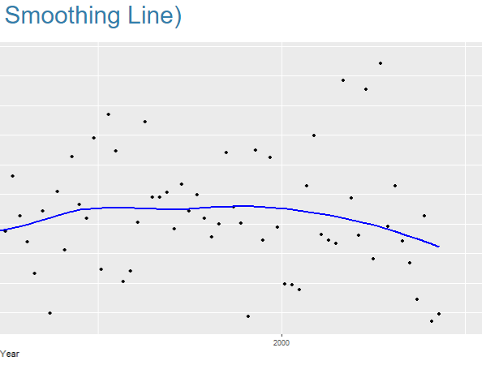

The low flows seem to be decreasing towards the end here, but over the full subset record I chose here (1992 to 2022), there isn’t a statistically significant change.

Step 8: Flow Scaling

It is possible that you are not trying to calculate these values directly at a gage. If you are trying to calculate these values close to the gage that you have been analyzing, you can use a simple ungaged area/gaged area ratio to calculate the up/downstream values. Ideally, the ungaged area should be within 50% of the gaged watershed area.

$$\left[0.50< \frac{Ungaged Watershed Area}{Gaged Watershed Area}<1.50\right]$$

Initially, the page should look like this:

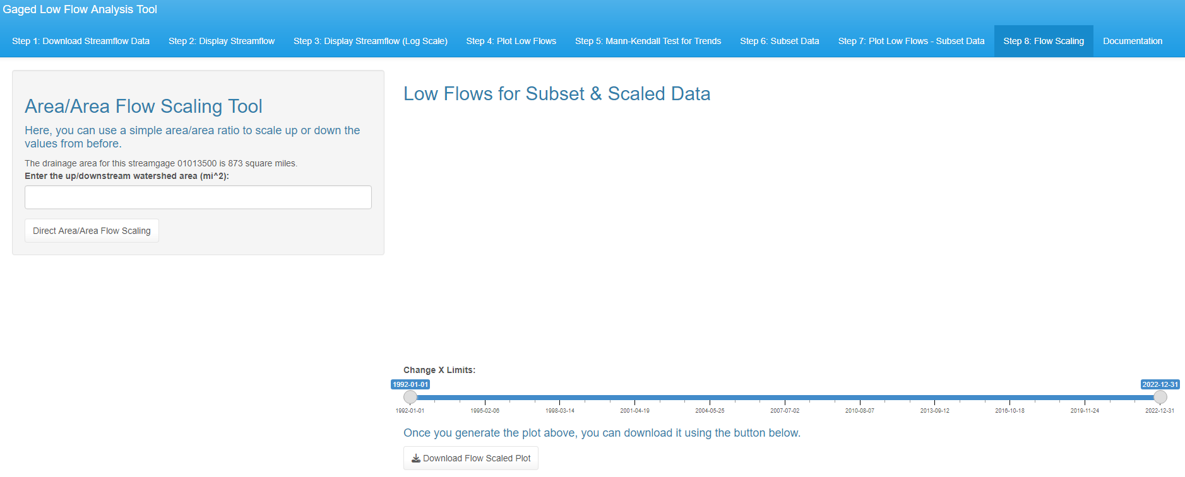

The drainage area for the gaged basin should be displayed in the box. For this example, the basin is 873 square miles, and we will use an upstream area of 500 square miles to create the ratio.

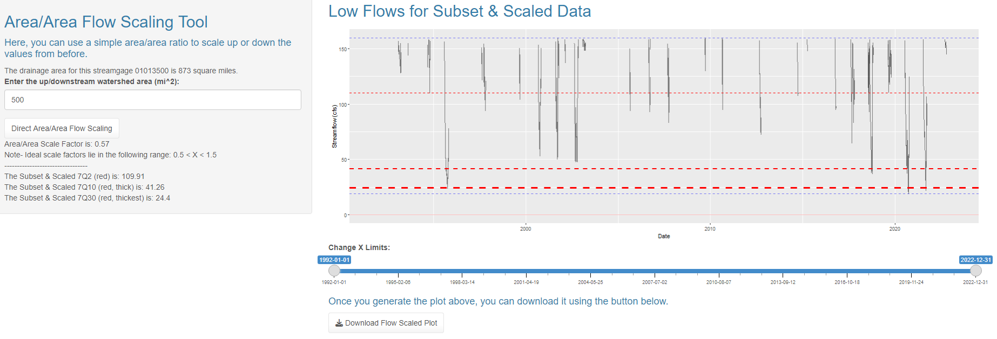

After entering the new area and pressing the button, the area/area ratio (or scale factor) should be displayed, as well as a reminder not to use ratios outside of the ideal range. In addition, the new 7Q2, 7Q10, and 7Q30 values are displayed in the box, as well as on the graphic.

This assumes that the area is homogeneous, and that runoff is similar throughout the entire watershed during low flow events. This is the generally accepted process for low flows, but it may not translate to average flows as well, so we have included the daily flow line as slightly transparent here. If you have reason to believe your low flows may not translate directly by area, you may want to use another methodology, or assume the watershed is completely ungaged. This methodology makes a lot of assumptions, so be careful if you decide to use this method. It should be appropriate if your location of interest is very close to a gage, but the further you go up or downstream, the more likely that this methodology is not appropriate.

Regression-Based 7Q10 Estimator for Ungaged Watersheds

Link: <https://andrewdelsanto.shinyapps.io/ungagedwatershedestimator/>

Description: This webtool is designed for assisting resource managers in calculating the 7-day-10-year low flow (7Q10) at purely ungaged locations. This follows the same procedure as the USGS’ StreamStats program but utilizes regional regression equations applied to all the New England states, and allows the user to calculate the 7Q10 using regression equations that were only trained on the last 30 years of streamflow data at every training location in the domain.

Summary of Steps:

1. Background Information
   1. Explanation of Tool
   2. Link to the USGS’ StreamStats Application
2. Contact StreamStats
   1. Enter a Valid Latitude and Longitude
   2. Press “Calculate”
   3. Success or Failure Displayed
3. Display Watershed and Characteristics
   1. Show Available Physical Characteristics
   2. Display StreamStats’ Estimated 7Q10 if Available
   3. Display the Watershed on a Leaflet Map
4. Regression-Based 7Q10 Estimation
   1. Show Results from Step 3 Again
   2. Enter Physical Characteristics
   3. Full-Record 7Q10 Estimates Given
   4. Recent 30-Year 7Q10 Estimates Given
5. Climate Change Projections
   1. Regression Equation with Altered-Climate Projections
6. Documentation
   1. Download Documentation
   2. Link to Science Base for project information

## Step by Step Walkthrough and Notes

Step 1: Background Information

When you open the program, it should bring you to a page that looks like this:

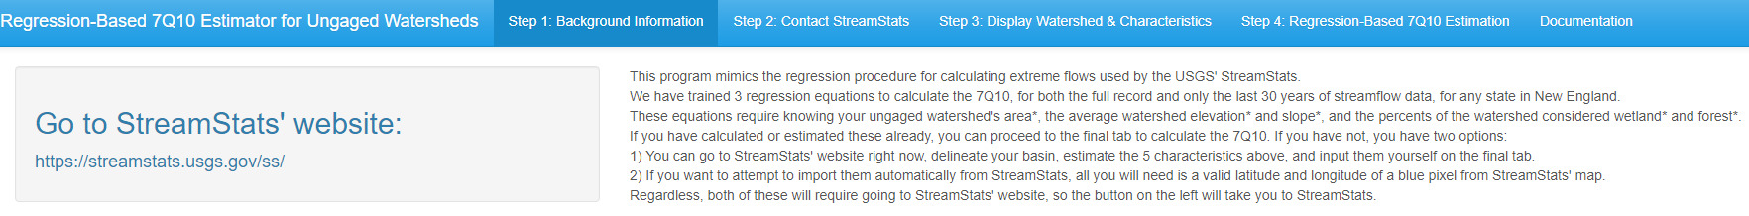

This page begins by explaining the process and letting you know that you can either get all of the information from StreamStats yourself or attempt to use the program to download everything you need.

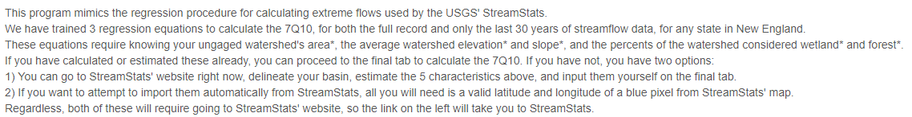

Regardless, you will need to find a valid point from StreamStats, so we have included a link to StreamStats that you can open in your browser.

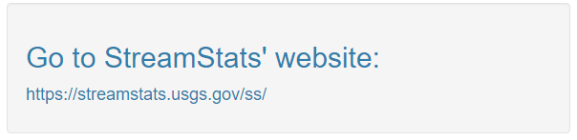

This should take you to this page:

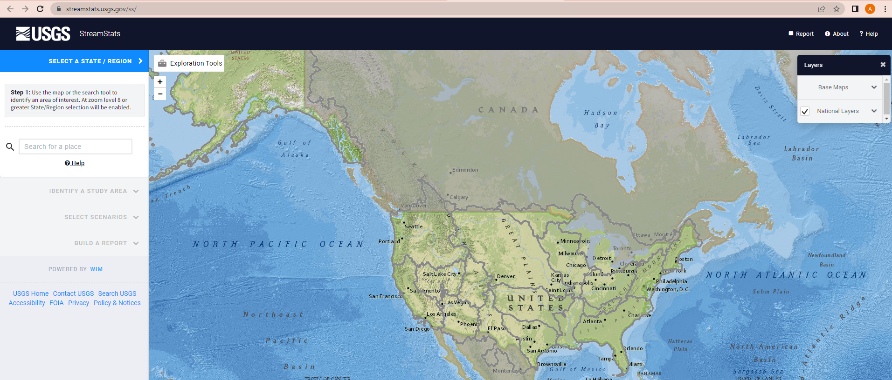

Step 2: Contact StreamStats

In this tab, we allow you to attempt to contact StreamStats. The page should initially look like this:

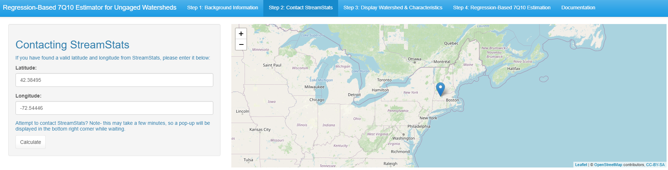

The default latitude and longitude go to the stream that passes through UMass. If you go to StreamStats and type in 42.38495, -72.54446, it should bring you to this location:

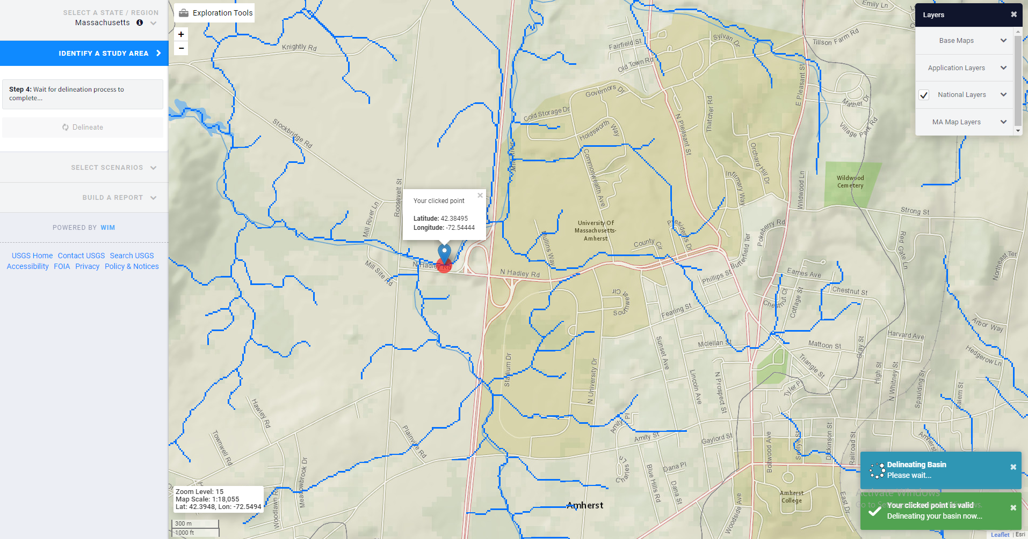

We recommend going to StreamStats and ensuring that StreamStats is able to delineate a watershed at the latitude and longitude you have selected. Notice that this one gives you the latitude and longitude and says “your clicked point is **valid**”.

Once you have a latitude and longitude that StreamStats recognizes as “valid”, return to the program, enter the latitude and longitude, and click “Calculate”. You may notice a small box pops up in the bottom right corner that tells you the program is in the process of contacting StreamStats:

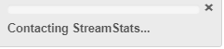

After a few minutes, this should pop up:

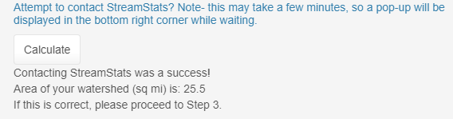

Note- if this does not, ensure that you are entering a valid latitude and longitude and try again.

Step 3: Display Watershed and Characteristics

In this tab, we display the watershed, the available physical characteristics that are needed for the regression equations, and if available, StreamStats’ own 7Q10 estimate. Note, depending on the state you are in, the physical characteristics and/or 7Q10 estimate may not be available.

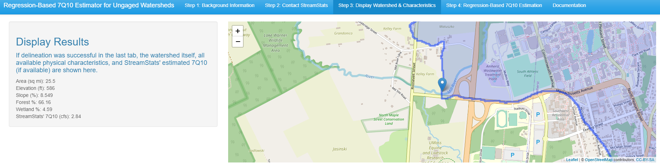

For Massachusetts, where UMass is located, all of the physical characteristics and the 7Q10 are available from StreamStats, so this is displayed:

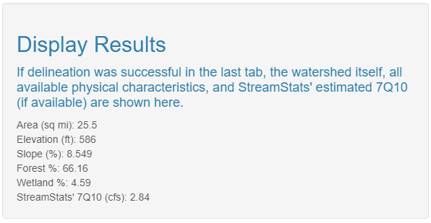

In addition, the delineated watershed is displayed in the main panel. We recommend comparing this to the watershed that you delineated on StreamStats’ website. If you found a valid point, StreamStats would have automatically delineated the watershed when you clicked, and it should look identical to the one that this program gives you.

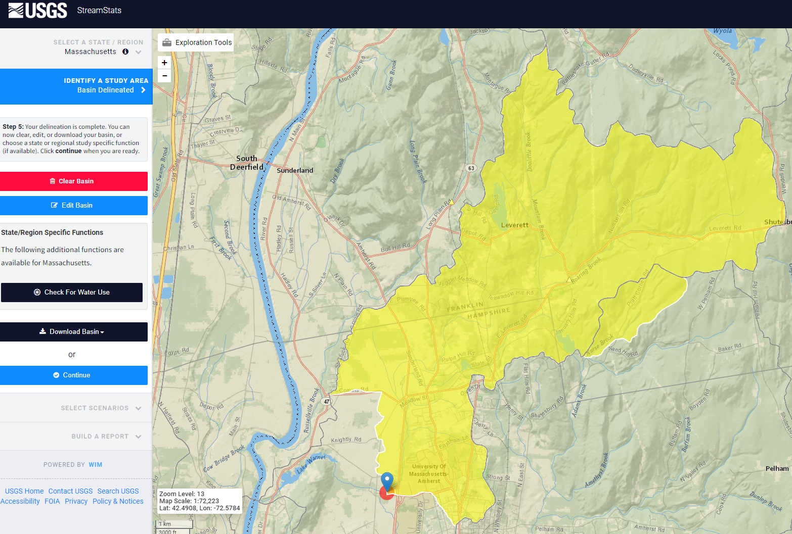 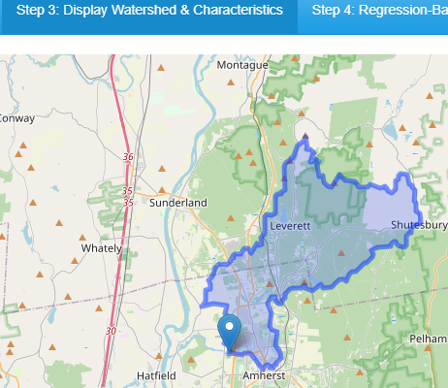

Step 4: Regression-Based 7Q10 Estimation

This page is where we use regression to estimate the 7Q10. If you have successfully delineated a watershed in Step 2, the physical characteristics and 7Q10 from StreamStats should auto-populate (if they are available for the state you are working in). If they are not, those will just be empty here.

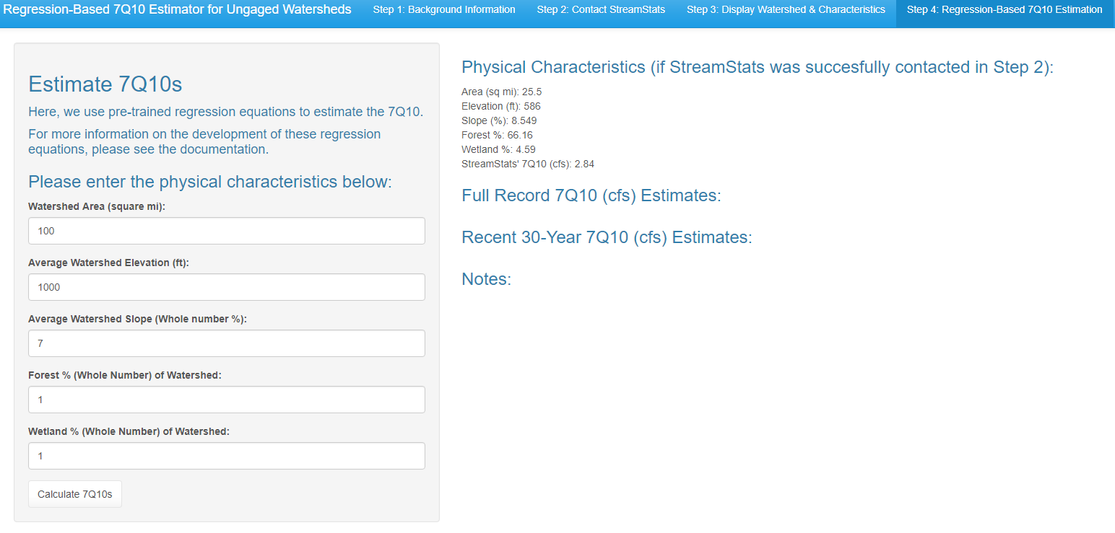

If these are not readily available for your state, it is not a big deal. The most important variables to the regression are area, elevation, and slope. You are guaranteed to get area from the delineation, and most states have slope and elevation included on StreamStats. If your state does not, you can usually estimate those using some type of computer program.

If you cannot get them anywhere, you can play around with the numbers to see how much they actually affect the estimate, and you may find out that there is a minimal difference between a watershed with a forest % of 10% versus 50%. If that is the case, you can use the average, or make your best guess.

After entering the correct values and pressing “Calculate 7Q10s”, everything should auto-populate, and the page should look like this:

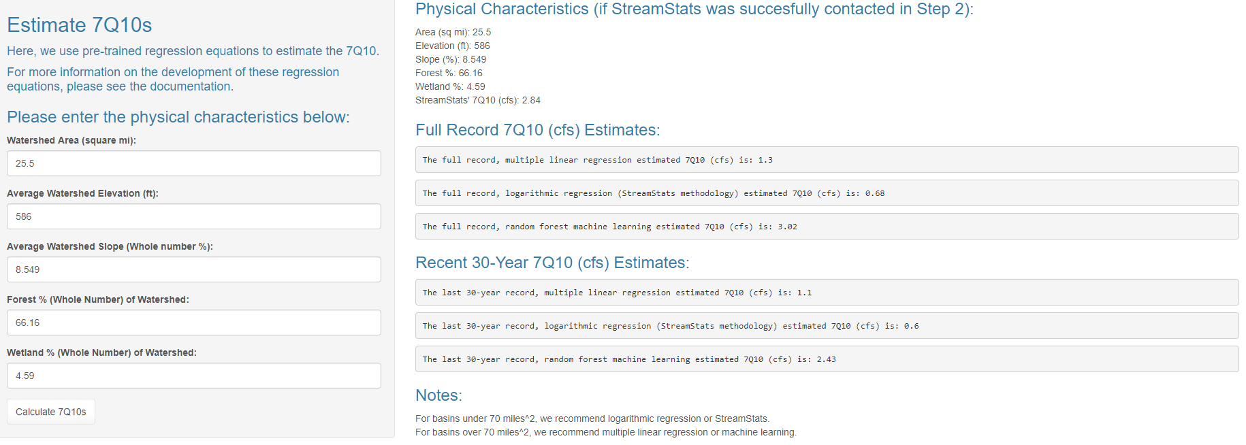

You can play around with the numbers after that, and the estimates should update in real time. We have also included a note that StreamStats and logarithmic regression perform best for small basins (under 70 square miles) and multiple linear regression and random forest (machine learning) perform best for larger basins (over 70 square miles).

For more information about how these values are calculated, we have included snippets of a paper we are in the process of publishing about this topic. Note- for the precipitation and temperature variables, we calculate these for you behind the scenes as you will not be able to find them anywhere.

**Table 1: StreamStats 7Q10 Estimation by State**

|  |  |
| --- | --- |
| **State** | **Variables Used for 7Q10 Estimation** |
| Massachusetts (Ries et al., 2000) | 1. Drainage Area, 2. Area of stratified-drift deposits per unit of stream length plus 0.1 3. Mean Basin Slope 4. An indicator variable, 0 in the eastern region, 1 in the western region |
| Rhode Island (Bent et al., 2014) | 1. Drainage Area 2. Stream Density |
| New Hampshire (Flynn et al., 2002) | 1. Drainage Area 2. Mean Annual Temperature 3. Jun to Oct Average Gage Precipitation |
| Maine (Dudley et al., 2004) | 1. Drainage Area 2. Fraction of Sand and Gravel Aquifers |
| Pennsylvania (Stuckey et al., 2006) | 1. Drainage Area 2. Elevation 3. Mean Annual Precipitation |
| Virginia (Austin et al., 2011) | 1. Drainage Area |
| West Virginia (Wiley, 2008) | 1. Drainage Area 2. Low Flow Region # 3. Mean Annual Precipitation 4. Percent Developed 5. Percent Carbonate |
| Connecticut, Delaware, Maryland, New Jersey, New York, Vermont | Unavailable |

Table 2: Input Variables for Estimating 7Q10

|  |  |
| --- | --- |
| **Variable** | **Description** |
| Area (mi2) | Watershed area |
| Mean Elevation (ft) | Average elevation of the watershed |
| Slope (%) | Average basin slope |
| Percent Wetland (%) | Wetland percentage of the watershed |
| Percent Forest (%) | Forest percentage of the watershed |
| Min 30-day Cumulative Precipitation (mm) | Lowest 30-day cumulative precipitation, limited to abnormally hot periods (X > 90th percentile temperatures) |
| Average 30-day High Temperatures (C) | Average 30-day temperature during the corresponding period of low cumulative precipitation |

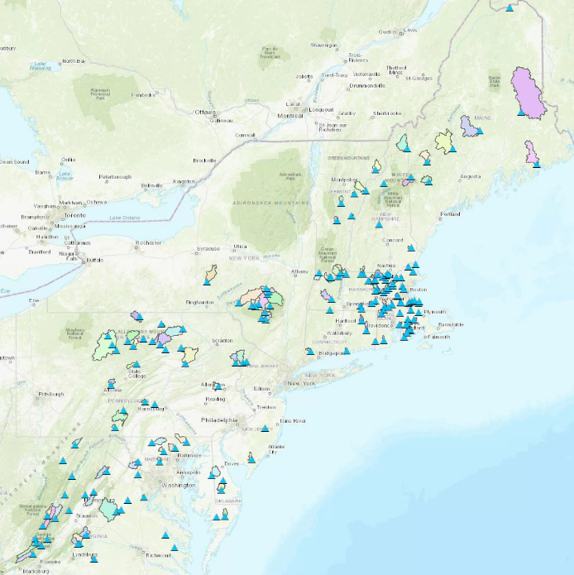

**Figure 1: The 165 gages and their corresponding watersheds used for this analysis**

Direct comparisons to StreamStats.

Table 6: Multiple Method Comparisons to Current Estimates

|  |  |  |  |  |
| --- | --- | --- | --- | --- |
| **Method** | **R2** | **KGE** | **NSE** | **RMSE** |
| StreamStats Estimates | 0.66 | 0.66 | 0.65 | 9.88 |
| Log-Transformed Linear Regression | 0.67 | 0.54 | 0.62 | 13.50 |
| Multiple Linear Regression | 0.70 | 0.80 | 0.63 | 7.14 |
| Random Forest | 0.63 | 0.76 | 0.53 | 7.97 |

More locations, since StreamStats isn’t available for every state in the domain.

Table 7: Comparisons Between Statistical Methods using Leave-One-Out-Cross-Validation

|  |  |  |  |  |
| --- | --- | --- | --- | --- |
| **Method** | **R2** | **KGE** | **NSE** | **RMSE** |
| Log-Transformed Linear Regression | 0.72 | 0.50 | 0.62 | 15.24 |
| Multiple Linear Regression | 0.60 | 0.73 | 0.47 | 8.53 |
| Random Forest | 0.61 | 0.69 | 0.41 | 8.39 |

Table 8: RMSE Comparisons Between Methods for Basin Size Subsets

|  |  |  |  |
| --- | --- | --- | --- |
| **Subset** | **RMSE – Multiple Linear Regression** | **RMSE – Log Regression** | **RMSE – Random Forest Regression** |
| Small Basins (< 15 mi2) | 2.11 | 0.34 | 0.44 |
| Medium Basins (15-70 mi2) | 3.96 | 2.83 | 3.09 |
| Large Basins (> 70 mi2) | 14.02 | 26.23 | 14.01 |
| Average | 6.70 | 9.80 | 5.85 |

Table 3: Multiple Linear Regression Variables & Significance

|  |  |  |  |
| --- | --- | --- | --- |
| **Variable** | **Estimate** | **P-Value** | **Significance** |
| Area (mi2) | 0.0579833 | 2e-16 | < 0.001 |
| Mean Elevation (ft) | 0.0014461 | 0.05343 | < 0.1 |
| Slope (%) | -0.2804801 | 0.00197 | < 0.01 |
| Percent Wetland (%) | -0.0618991 | 0.27690 | No significance |
| Percent Forest (%) | 0.0048811 | 0.86061 | No significance |
| Min 30-day Cumulative Precipitation (mm) | 0.3421899 | 0.00246 | < 0.01 |
| Average 30-day High Temperatures (C) | -0.0466718 | 0.58980 | No significance |

$7Q10= 0.0579833*\left(Area\right)+ 0.0014461*\left(Elevation\right)- 0.2804801*\left(Slope\right)- 0.0618991*\left(Wetland\right)+ 0.0048811* \left(Wetland\right)+ 0.3421899*\left(Precip\right) - 0.0466718*(Temperature)$

(R Square = 0.7481, Residual Standard Error = 7.693, P-Value = 2e-16)

Table 4: Logarithmic-Transformed Linear Regression Variables Tested for Significance

|  |  |  |  |
| --- | --- | --- | --- |
| **Variable** | **Estimate** | **P-Value** | **Significance** |
| Intercept | 4.27157 | 0.1590 | No significance |
| Area (mi2) | 1.31308 | 2e-16 | < 0.001 |
| Mean Elevation (ft) | -0.11573 | 0.2908 | No significance |
| Slope (%) | -0.19413 | 0.0303 | < 0.05 |
| Percent Wetland (%) | -0.02036 | 0.7542 | No significance |
| Percent Forest (%) | 0.22437 | 0.0489 | < 0.05 |
| Min 30-day Cumulative Precipitation (mm) | 0.31049 | 0.0160 | < 0.05 |
| Average 30-day High Temperatures (C) | -4.37462 | 0.0309 | < 0.05 |

$$\log\left(7Q10\right)= 4.27157+ 1.31308*log\left(Area\right)-0.11573*log\left(Elevation\right)- 0.19413*log\left(Slope\right)-0.02036*log⁡(Wetland)+0.22437*\log\left(Forest\right)+ 0.31049*log\left(Precip\right) -4.37462*log(Temp)$$

R Square = 0.67, Residual Standard Error = .6139, P-Value = 2e-16

Table 5: Random Forest Variables Test for Significance

|  |  |  |  |
| --- | --- | --- | --- |
| **Variable** | **% Included MSE** | **P-Value** | **Significance** |
| Area (mi2) | 57.580982 | 0.0099 | < 0.01 |
| Mean Elevation (ft) | 6.911398 | 0.03465 | < 0.05 |
| Slope (%) | 2.257348 | 0.07228 | < 0.1 |
| Percent Wetland (%) | -2.099959 | 0.9901 | No significance |
| Percent Forest (%) | 3.335443 | 0.08911 | < 0.1 |
| Min 30-day Cumulative Precipitation (mm) | 7.726635 | 0.04275 | < 0.05 |
| Average 30-day High Temperatures (C) | 1.265636 | 0.6634 | No significance |

Step 5: Regression-Based Future 7Q10 Estimation

Given the importance of both climate variables, we can use the regression equations to “simulate” future climate change by altering the climate variables to what is projected to happen in the near future. This the procedure recommended by the Federal Highway Administration from *NCHRP 15-61: Applying Climate Change Information to Hydrologic and Hydraulic Design of Transportation Infrastructure* (https://apps.trb.org/cmsfeed/TRBNetProjectDisplay.asp?ProjectID=4046).

Using 9 GCMs for both RCP4.5 and RCP8.5, we have extracted the average projections from 2020-2060 and 2060-2100. We found that temperatures are undoubtedly going up, but there is a wider range of precipitation changes predicted. On average, precipitation was increasing in the RCP4.5 short-term (2020-2060), but for all other scenarios, the summer (JJA) precipitation is projected to remain the same or decrease. We theorize this is because temperature changes have been minimal to this point while precipitation has increased, but as temperatures begin to increasingly accelerate, precipitation will begin to decrease due to increased evapotranspiration and warmer air’s ability to store more water. These are highlighted in the following figures.

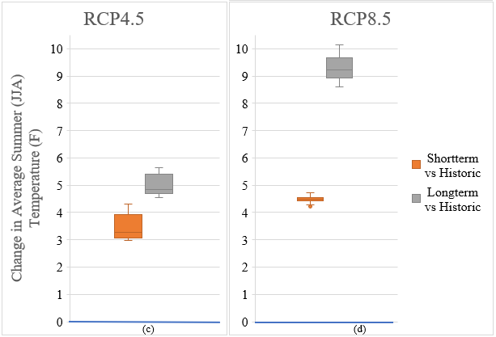

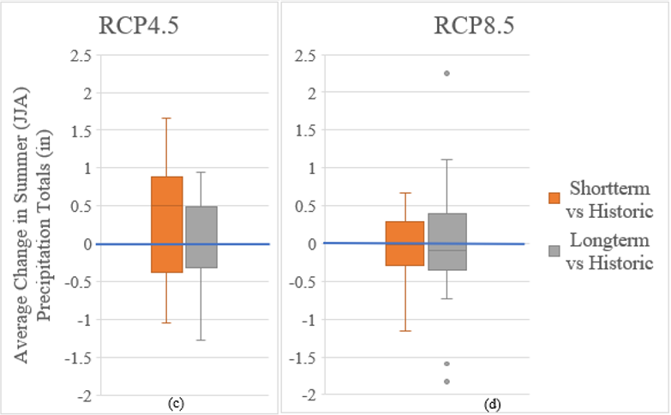

Based on the mean projected changes (similar to the median values above but varying slightly), we have created the following tool, which requires a 7Q10 estimate, and allows the user to alter the climate scenarios given the thresholds that we have found using the GCMs to project a new climate-altered projection using the Logarithmic-Regression equation.

